Annual Business Report 2024
Comprehensive Analysis and Future Outlook

Executive Summary
This report provides a comprehensive overview of our company's performance in 2024. Key achievements include: revenue growth of 25%, expansion into 5 new markets, and the successful launch of 3 innovative products.
- Revenue increased by 25% year-over-year
- Customer satisfaction rating improved to 94%
- Employee retention rate reached 92%
- Carbon footprint reduced by 15%

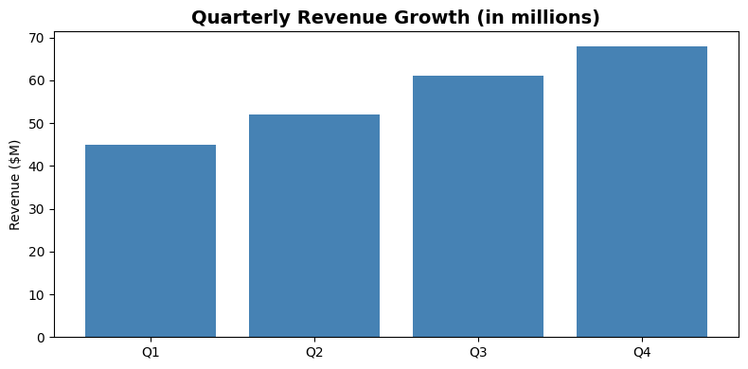

Performance Metrics
Metric | Target | Actual
Revenue Growth | 20% | 25%
Customer Acquisition | 5,000 | 6,200
Market Share | 15% | 18%
Product Launches | 2 | 3

Future Outlook
Looking ahead to 2025, we are optimistic about continued growth. Our strategic initiatives include:
- Digital transformation across all departments
- Expansion into Asian markets
- Investment in sustainable technologies
- Enhanced customer experience programs


